Didactic Program in Dietetics

West Virginia University

Division of Animal and Nutrition Sciences

Davis College of Agriculture, Natural Resources and Design

2023-2024

Student Handbook

DPD Director: Kelli S. George, PhD, RDN

Division Director: Chris Ashwell, PhD

DAVIS COLLEGE OF AGRICULTURE, NATURAL RESOURCES AND DESIGN
SCHOOL OF AGRICULTURE AND FOOD

Table of Contents

Program Contact Information 2
Program Description, Mission and Goals 2
Program History 3
Accreditation Status 3
Career Opportunities for an RDN 3
Requirements for becoming a Credentialed RDN 5
Graduation Requirements 5
DPD Curriculum 6
Admission to the Dietetics Program 6
Assessment of Prior Education 7
Academic Advising 7
Student Performance Monitoring 7
Building your Resume for Dietetic Internship Matching 8
Verification Statements 9
Internship Matching 9
Costs to Students 11
Awards 11
Scholarships 11
Professional Behavior, Student Conduct, and Academic Integrity 12
Disciplinary Procedures 12
Student Complaints 13
Additional Policies and Procedures 13

Appendices
Appendix A: Program Curriculum 16
Appendix B: Suggested Plan of Study – HN&F Major 19
Appendix C: Suggested Plan of Study – AoE in Dietetics 21
Appendix D: DICAS Computer Matching Calendar 2021-2022 23
Appendix E: Pre-Professional Additional Course Requirements 27
Appendix F: Individual Assignments with Minimum Grade Requirements 28

Program Contact Information
DPD Director
Kelli S. George, PhD, RDN
Kelli.george@mail.wvu.edu
Office: 304-293-1887

Program Description, Mission and Goals
The undergraduate Didactic Program in Dietetics (DPD), accredited by the Accreditation Council for Education in Nutrition and Dietetics (ACEND), prepares students for a career as a Registered Dietitian Nutritionist (RDN), graduate school and employment, and provides the academic requirements necessary for eligibility to apply to an ACEND-accredited supervised practice program, which is required for eligibility to sit for the Registration Examination for Dietitians offered by the Commission for Dietetic Registration (CDR), thus obtaining the RDN credential.

The mission of the West Virginia University DPD is to prepare students for entry into supervised practice programs in dietetics leading to eligibility for the CDR credentialing exam to become a registered dietitian nutritionist by providing an in-depth educational experience with practical applications and a strong community nutrition component.

The program’s goals and objectives reflect the program’s mission:

Goal 1. Program graduates will be well-prepared for a dietetics supervised practice program, leading to eligibility for a career in dietetics.

Objective 1a. At least 60% of program graduates apply for admission to a supervised practice program prior to or within 12 months of graduation
Objective 1b. Of program graduates who apply to a supervised practice program, at least 90% are admitted within 12 months of graduation
Objective 1c. The program’s one-year pass rate (graduates who pass the registration exam within one year of first attempt) on the CDR credentialing exam for dietitian nutritionists is at least 80%
Objective 1d. At least 80% of program students complete the program/degree requirements within 3 years (150% of program length)
Objective 1e. 90% of Supervised Practice Program Directors will rate program graduates as “well-prepared” for supervised practice
Objective 1f. 90% of program graduates who enter a dietetics supervised practice program will indicate they were well-prepared for supervised practice.

Goal 2. The program will provide graduates with basic knowledge and skills that will prepare them for continued professional growth and development in the field of nutrition and dietetics.

Objective 2a. At least 80% of graduates will be confident or very confident in their ability to integrate basic knowledge and managerial skills related to nutrition and dietetics.
Objective 2b. At least 90% of Supervised Practice Program Directors will report that they are satisfied or very satisfied with the ability of WVU DPD graduates to integrate basic knowledge and managerial skills related to nutrition and dietetics during their supervised practice experience.
Objective 2c. At least 80% of graduates will feel confident or very confident in their written and oral communication skills.
Objective 2d. At least 90% of Supervised Practice Program Directors will report that they are satisfied or very satisfied with the written and oral skills of WVU DPD graduates.
Objective 2e. At least 80% of graduates will feel confident or very confident in their problem solving and critical thinking skills.
Objective 2f. At least 90% of Supervised Practice Program Directors will report that they are satisfied or very satisfied with the problem solving and critical thinking skills of WVU DPD graduates.

The major learning outcomes of the program include:
1. Graduates will acquire a high level of competency in the basic sciences required for disciplinary competency.
2. Graduates will integrate basic knowledge and managerial skills related to the nutritional and food science disciplines.
3. Graduates will acquire sufficient written and oral communication skills, problem solving and critical thinking skills to effectively impact lifelong societal and professional developments critical to their respective discipline of interest.
4. Graduates will attain depth of knowledge relative to the scope of subfields of human nutritional sciences.

Program History
The West Virginia University Didactic Program in Dietetics has been accredited since 2000. In 2000, the DPD was part of the Human Nutrition and Foods (HN&F) major, housed in the Division of Family and Consumer Sciences. In 2005, HN&F moved to the Division of Animal and Nutritional Sciences to enhance program synergy with undergraduate programs in food science and technology and nutritional biochemistry. There has consistently been one track delivered in a classroom setting that led to a Bachelor of Science degree in the Davis College of Agriculture, Natural Resources, and Design. Typically, 70 to 75 students are in the DPD each year.

Accreditation Status
The Didactic Program in Dietetics at West Virginia University is currently accredited by the Accreditation Council for Education in Nutrition and Dietetics (ACEND) of the Academy of Nutrition and Dietetics. ACEND establishes standards for dietetics education program. This program meets the 2017 ACEND Accreditation Standards.
ACEND® can be contacted by:
Mail: 120 South Riverside Plaza, Suite 2190, Chicago, Illinois 60606-6995
Email: ACEND@eatright.org
Phone: 800/877-1600, ext. 5400

Career Opportunities for an RDN
A dietitian (RDN) is a health professional who assists people of any age to achieve optimal nutrition status. Dietitians are trained mainly in foods and nutrition, but also in social sciences, education, business and management. This diverse background prepares a dietitian to apply both the science and art of human nutrition to those from diverse cultures, with varying nutrition needs. There are many different specialties within the field of dietetics, and dietitians often pursue more than one over the course of their career. Some of the major areas for career opportunities include:
- Business and Industry. Work in a variety of fields including sales/promotion (marketing), worksite wellness programs, product development, and social media.
- Clinical Dietitian. Assess nutritional needs, develop individual dietary plans, educate and counsel patients and work with the health care team to improve patient health. Clinical dietitians may work in hospitals, nursing homes, or outpatient settings.
- Sports Dietitian. Work with athletes at the individual, collegiate, or professional levels on proper nutrition for peak performance.
- Community Nutrition. Assess nutritional needs of population groups. Plan and coordinate nutritional aspects of programs aimed at improving health and preventing disease in the community.
- Food Service Management. As part of the management team these dietitians plan, organize, direct and evaluate food service systems. Budgeting, employee training, personnel management, recipe development, establishing and maintaining policies and standards, etc. Employers include schools, senior centers, healthcare facilities, hotels or restaurants.
- Private Practice. For this field prior work experience in dietetics is often necessary. These entrepreneurial dietitians are usually self-employed and provide advice on services in nutritional care, food service management or consumer education.
- Education/Academia. Plan, implement, and evaluate educational experiences for dietetic or other health students in college, as well as nutrition classes for preschool and K-12 students. Employers include universities, acute care facilities or community programs. Advanced education in nutrition and education is generally required (master’s and/or doctoral degree).
- Research. This field requires advanced education in research techniques and, often, an advanced degree. Typically a research dietitian would work closely with the other investigators in planning and implementing projects that investigate nutrient needs, functions, interactions, etc. in humans or animals. Research activities may be incorporated in all areas of dietetics. Employers can include universities and industries.
The average starting salary (years 1-4) for RDNs is $30/hour. The national median salary for all RDNs is $69,600 (AND, Compensation & Benefits Survey, 2019). Salary varies depending on years of experience, length of employment, regional location, and type of position held. Employment opportunities nationwide are currently excellent. The emphasis on nutrition and health, and preventative health, in this country enhances demand for RDNs. For more information, consult the Academy of Nutrition and Dietetics website at www.eatright.org.
Career opportunities also exist for students in the Dietetics program that do not match to a dietetic internship or do not wish to become a Registered Dietitian:
- Dietetic Technician, Registered. Upon receiving a verification statement, students are eligible to take the nDTR exam. This credential allows you to work in healthcare and food service operations. More information can be found at: http://www.eatright.org/BecomeanRDorDTR/content.aspx?id=8144
- Health educator
- Health or food industry sales
- Certified Dietary Manager, foodservice supervisor or management
- Graduate school
A degree in Human Nutrition & Foods is also a pathway to other health-related career opportunities. Students interested in medical school, physician assistant school, and other health or medical careers can benefit from a background in nutrition before moving on to the respective pre-professional programs. Students with these career goals should also be aware of specific pre-requisites for entrance into those programs, as there may be additional requirements outside of what is required for a degree in HN&F.
See Appendix E for additional common pre-professional course requirements.

Requirements for Becoming a Credentialed RDN
The path to become a registered dietitian nutritionist includes a college degree, completing a dietetic internship from an ACEND-accredited program, and passing the national registration exam. At WVU, students who wish to become a registered dietitian nutritionist must:
- Earn a bachelor’s degree and complete the Didactic Program in Dietetics (DPD) curriculum with a cumulative GPA of 2.75;
- Apply for and complete an ACEND-accredited dietetic internship program or Individual Supervised Practice Pathway;
- Pass the Commission on Dietetic Registration’s dietetic registration exam;
- Gain licensure if required in your state of practice;
- Maintain continuing education. Note that in 2024, a graduate degree will be required to be eligible to take the Commission on Dietetic Registration exam.
*In addition to the ACEND-accredited undergraduate DPD, WVU offers an ACEND-accredited dietetic internship associated with a master’s degree. An undergraduate degree from WVU does not guarantee acceptance into the WVU dietetic internship.

Graduation Requirements
Requirements for graduation from the program include:
- Passing all courses in the program curriculum
- Meeting University requirements for graduation:
  - 120 total credit hours
  - Meeting GEF course requirements
  - Capstone course
  - Residence requirements
- Minimum cumulative GPA of 2.75
- Minimum letter grade of C- in all HN&F courses
Please see the WVU Academic Catalog for details on University graduation requirements: http://catalog.wvu.edu/undergraduate/degree_regulations/#Undergraduate_Degree_Requirements

DPD Curriculum
Students majoring in Human Nutrition & Foods have the option to declare an Area of Emphasis (AoE) in Dietetics. Any student who wishes to become a credentialed RDN should declare the AoE in Dietetics in order to complete the DPD Curriculum. The DPD Curriculum is the same as the degree curriculum, with the exception of free electives required. To complete the DPD Curriculum, students must declare the Area of Emphasis (AoE) in Dietetics. Students must meet with their advisor to declare the AoE, must have a minimum GPA of 2.75, and have completed HN&F 271 and CHEM 115 and 115L to be eligible for the Area of Emphasis in Dietetics. Students must declare the Area of Emphasis no later than September 1 of the academic year in which they will be requesting a verification statement.

To receive a Didactic Program in Dietetics Verification Statement to sit for the Nutrition and Dietetics Technician Registered (NDTR) exam or to apply for dietetic internships students must:
- Graduate from the Human Nutrition & Foods major with a minimum GPA of 2.75,
- Complete the Area of Emphasis in Dietetics,
- Earn a minimum grade of C- in all HN&F courses, and
- Meet minimum individual assignment grade requirements within specified HN&F courses (see appendix F).

Completing DPD Requirements Outside of a Bachelor’s Degree
Graduate students or others who have previously obtained a bachelor’s degree can complete the DPD curriculum to receive a verification statement. Note the DPD curriculum is not distance based and must be completed on West Virginia University’s campus. Please contact the DPD Director for more information and guidance with this option.

Admission to the Dietetics Program
Students who are admitted to WVU can be admitted to the DPD by declaring Human Nutrition and Foods (HN&F) as a major. Students enter the DPD after their sophomore year by letting their faculty advisor know of their interest in dietetics. WVU students in majors other than HN&F who wish to transfer into the DPD must begin with their current academic advisor to initiate a change in major. Those students will be accepted into the HN&F major and will work with their HN&F faculty advisor to meet DPD course requirements.
Information about admission to WVU and how to apply can be found on the WVU Admissions website.
Potential for success during the first two to three semesters is based on grades in freshman and sophomore science and HN&F classes. Students who are unable to pass Fundamentals of Chemistry the first time they take it or who make less than a B average on HN&F classes are unlikely to be successful in the more rigorous upper level DPD classes and they’re advised accordingly.
Students in the DPD are required to complete core courses as well as courses in food science, nutrition, food service management, sociology, psychology, economics, chemistry, biology, physiology, and microbiology, and required electives for the DPD. A comprehensive list of courses is available through the WVU course catalog.

Assessment of Prior Education
There is no opportunity to receive credit for prior learning (CFPL) in the DPD. However, WVU offers a Regents Bachelor of Arts for non-traditional students in which students may receive CFPL in some of their other required courses through portfolio submission or standardized tests and they may use that credit to meet general education foundation requirements prior to admission to the DPD. Students may transfer credit for DPD courses from other institutions. Assessing transfer credit begins in the university Registrar’s office which will decide whether a course is transferred as equivalent to a WVU course or not. The Registrar’s office will typically ask the WVU instructor to determine equivalency of a DPD course from another institution. To do so, the WVU instructor will review the syllabus of the transfer course for equivalent core Knowledge Requirements for Registered Dietitian Nutritionists (KRDNs) to determine whether the transfer course will fulfill the WVU DPD requirements.

Academic Advising
All HN&F majors have a faculty advisor. It is important that students meet with their faculty advisor early in their academic career. Students are required to meet with their advisor at least twice per year, once in the Fall Semester, and once in the Spring Semester. These meetings are required before you can register for classes. If students do not meet with their advisor, a hold will be placed on their student account and they will not be able to register for classes until the hold is lifted, by meeting with their advisor.
To find the contact information for your advisor, follow these steps:
- Login at http://portal.wvu.edu
- Click the yellow DegreeWorks button
- Locate your advisor’s information under the Student View section
Academic advisors help guide students toward which classes to take, add minors, change majors or add a double major, meet graduation requirements, meet financial aid requirements, and provide career advice, as applicable.
Students’ should follow the advisor’s guidance on which classes to register for each semester, but students must register for the classes themselves through STAR or Schedule Builder. Students are encouraged to register for classes as soon as possible. Classes fill up quickly, and late registration will result in additional fees added to tuition (University rule) for each semester that this occurs.
Students receiving federal and/or state financial aid may have additional course and/or credit hour requirements each semester in order to keep scholarships in future years, and/or receive full financial aid disbursement. Any and all aid/scholarships should be discussed with the academic advisor to ensure requirements are met.

Student Performance Monitoring
DPD students who struggle to maintain at least a B average, which is required for a DPD verification statement, have access to tutoring through the Davis-Michaels Scholars Tutoring Program. A student with an overall grade point average below 2.0 will be placed on academic probation and may be subject to suspension. Every student placed on academic probation must enter into a contract with the college. See the WVU Probation and Suspension website for more information. DPD students who face academic probation will be required to meet with their HN&F advisor to develop an individualized plan for success.
Students who have minimal chances of success in the DPD program will be counseled by their academic advisor into other career paths. Those students who struggle to get passing grades in freshman and sophomore level chemistry, biology, and nutrition classes are counseled to choose a career other than dietetics or nutrition because those careers are based on a foundation of biochemistry, physiology, and microbiology. Students who maintain a GPA between 2.0 and 3.0 are less likely to match to a supervised practice experience as required for the Registered Dietitian credentialing exam and may consider other career options related to food and nutrition such as dietetic technician, registered or food service management.

Building a Resume for Dietetic Internship Matching
Dietetic Internship matching can be very competitive, therefore we recommend that students take the initiative to go above and beyond in both academics and extracurricular activities. To be a strong candidate for a dietetic internship, the higher the GPA the better. It is also recommended that you obtain volunteer or work experience in any realm of the dietetics field prior to applying to dietetic internship programs. Experience can include shadowing experience as well. Suggested locations for any volunteer or work experiences include, but are not limited to: clinical settings such as a hospital or skilled nursing facility; a community setting such as a public health program or school garden; a large-scale foodservice operation such as University Dining or a school nutrition program. Keep in mind that the length of your experience and a variety of experiences are emphasized by internships.
WVU, Morgantown, and the surrounding areas offer many opportunities for volunteer and/or work experience related to nutrition and dietetics. These include but are not limited to:
- The Rack – WVU Student Food Pantry
- WVU Athletics Fueling Station
- Meals on Wheels
- Ruby Memorial Hospital
- Mon Health Medical Center
- WVU Dining Services
- Catholic Charities Food Pantry
- WELLWVU Student Wellbeing Ambassador Team
- Morgantown Community Kitchen
- Mon County Senior Center
- The Shack Neighborhood house
The Division of Animal and Nutritional Sciences itself offers various opportunities to enrich your resume, such as undergraduate research opportunities, study abroad trips, independent study, undergraduate teaching experience, and credits for professional field experience. As available, information about local opportunities will be provided via email and during your advising meetings.
We also recommend that students get involved in student and professional organizations by joining, participating and holding a leadership role in organizations such as: the Academy of Nutrition and Dietetics (AND), the West Virginia Academy of Nutrition and Dietetics, and the WVU Student Association of Nutrition and Dietetics (SAND). Each organization offers leadership roles, some offer scholarships, and each offer ways to get involved with the profession.

Verification Statements
Students who complete the DPD requirements and earn an overall GPA of 2.75 are eligible for a verification statement. Eligibility for a verification statement is established through a list of students who are cleared for graduation and a review of the academic records in Degree Works. If all DPD requirements are met at graduation, signed copies of a verification statement will be generated for mailing to an address provided by the student. Additional copies are kept on file in the program director’s office. A verification statement confirms that you have completed the DPD requirements and are eligible to apply for and complete an ACEND-accredited supervised practice program, such as a Dietetic Internship or Individualized Supervised Practice Pathway.
Programs requirements to earn a DPD verification statement include the following:
- Completion of DPD course requirements with minimum grade standards
- Completion of a bachelor’s degree
- Minimum university cumulative GPA of 2.75
- Minimum letter grade of C- in all DPD courses
Students already in possession of a bachelor’s degree or higher and pursuing DPD requirements will receive verification statements when they satisfactorily complete DPD coursework or a combination of DPD coursework plus equivalent courses. The DPD director will review the academic record in Degree Works to see that all requirements have been met prior to issuing a verification statement.
You will be provided with three signed copies of your verification statement, mailed to you within 5-6 weeks after program completion. An original copy is required to submit to your Dietetic Internship Director before beginning a dietetic internship and must be provided to sit for the NDTR exam. The DPD Director will retain two signed copies of the verification statement on file indefinitely.

Internship Matching
Students who wish to apply for a supervised practice program (dietetic internship) after graduation must have a cumulative GPA of 2.75 or higher, a cumulative GPA of 2.75 in major courses, and at least a C- in HN&F courses to receive a verification statement. During their senior year, students who will complete the DPD course requirements with a GPA of 2.75 or higher are eligible to apply for a dietetic internship by participating in a national computer-based matching system. The DPD Director will assist you in applying to dietetic internships; however, it is your responsibility to initiate and complete the process. Using the computerized matching service, Dietetic Internship Centralized Application Services (DICAS), students can apply to one or more programs, but if matched will only receive one match.
ACEND-Accredited Dietetic Internships include a minimum of 1000 hours of supervised practice that is required to take the RDN credential exam. Internships can require relocation (on-site) or can be completed as distance education at the location of your choice. Most internships require you to work full time (40-hour work weeks for 9-12 months), but some offer part-time work weeks that take longer to complete (18-24 months). You can also complete a stand-alone dietetic internship or apply for a combination internship that combines internship hours with either graduate credit or a graduate degree. Each program can have different application requirements, so plan early and accordingly.
Internship applications are submitted through DICAS, an online application system. The computerized matching process is completed through D&D Digital, a computerized matching system. There are two application/match cycles each year: a fall match (September 25 deadline) and a spring match (February 15 deadline). The fall match is generally for programs beginning in January, while the spring match is generally for programs that begin June-August. Please note that a few internships do have alternative deadlines, so plan early and accordingly. Additionally, not all programs participate in the fall match cycle.
Acceptance into an internship is competitive and is not guaranteed. A dietetic internship typically involves an additional one to two years, depending on the site and whether graduate study is included. Upon completion of the internship, the graduate is eligible to take a national examination sponsored by CDR to become an RDN.
You may choose to delay application beyond your last semester of coursework; however, it is best to keep the delay a short as possible. If the delay is extended to multiple years, know that some internships may require you to retake courses to meet their course recency criteria.
Successful completion of the DPD and receipt of a DPD Verification Statement does not guarantee acceptance into an ACEND-accredited dietetic internship. You will compete for placement in a dietetic internship in a computerized-matching process operated by ACEND. A full listing of ACEND-accredited dietetic internships may be found at http://www.eatrightpro.org/resources/acend/accredited-programs/dietetic-internships
Special Internship Pre-Select Opportunities for WVU Undergraduate Students
There are two opportunities for pre-select into a dietetic internship, exclusively for WVU undergraduate students. This means that in the Fall of the senior year, students may apply early to an internship program, and get accepted earlier than the traditional match date in the Spring. This also bypasses the need to apply through the DICAS system, eliminating the need to pay for DICAS and D&D Digital match fees.
WVU MS/DI Pre-Select: Two spots each year in the WVU MS/DI program are reserved as pre-select seats, whom only WVU undergraduate DPD students can apply for. Applications for these spots open in Fall of the graduating year, allowing the student to begin the MS/DI program in the Spring of their senior year, to begin graduate coursework and/or thesis-related research, and to bypass the DICAS and match application process. This program is a 2-year program, on site in Morgantown, WV.
Keiser University Distance MS/DI Pre-Select: Up to 12 students each year are eligible to apply for a pre-select seat in the early Spring of their senior year for the Spring match cycle, or in August for the Fall match cycle. Spring match cycle has an August start date and Fall match cycle has a January start date. Pre-select students get acceptance prior to DICAS match day and are eligible for a scholarship for up to 25% of tuition rates. This program is a 1-year distance program, with one required orientation week on-site in Florida. For more information, contact your DPD Director, Kelli George.
Options When Not Matched to an Internship
If you do not match with an ACEND-accredited dietetic internship on your first attempt, you may try again. There is no limit to how many times you can apply. Many students who do not match on the first attempt are able to match on their second attempt. If you do not match on your first attempt, you may seek assistance from the Program Director to identify strategies to strengthen your application for subsequent application cycles. If you apply to internships beyond graduation, you may continue to receive help from the Program Director.
Pathway I - Individual Supervised Practice Pathway (ISPP) - If you do not match to an internship on your first attempt, you are eligible to apply to an Individual Supervised Practice Pathway (ISPP). These are ACEND-accredited alternatives to dietetic internships – internship spots available only to those who have had one unsuccessful application match attempt. During your first attempt, you may apply to ISPPs in the second round of that first match cycle; or you can apply to ISPP during the first round of subsequent match cycles.
Pathway II – Nutrition and Dietetics Technician, Registered (NDTR) - DPD Graduates are eligible to sit for the national Registration Examination for Dietetic Technicians. Upon successful completion of the exam, you will have earned the dietetic credential Nutrition and Dietetics Technician, Registered (NDTR). Having this credential is one strategy for strengthening your application to dietetic internships. The Program Director can assist you in the process needed to take the NDTR Exam.
Costs to Students
Estimated cost of attendance includes direct costs such as University tuition and fees, college tuition, room and meals if living on campus, student health insurance, and materials and instruments. Estimated costs to students and information about financial aid can be found at WVU Admissions. Indirect costs may include books and on-line materials for specific courses, supplies, late registration fees, student membership fees to SAND or WVAND, personal expenses, transportation costs, room and meals if living off campus.
Information about availability of financial aid, scholarships, stipends and other support is available at WVU Admissions and Davis College websites.
Awards
All HN&F students are eligible for the “Outstanding HN&F Student” award, given every year to one student from the freshman, sophomore, junior, and senior classes. Students can self-nominate or be nominated by faculty. Award details are announced yearly via email and info screens, and winners are announced each April. Students in the HN&F major are also eligible for any WVU awards or recognition, such as Dean’s List, President’s List, WVU or Davis College scholarships or grants, etc.
Scholarships
The Academy of Nutrition and Dietetics Foundation offer recognition awards, leadership recognition and education stipends to members and dietetic student members. It is the largest provider of dietetic scholarships to deserving students at all levels of study. The number of scholarships varies from year to year, each with a value range of $500 to $10,000 each. See the Foundation's website for more information about its scholarships
Please visit the Scholarship page here to learn more about scholarships offered by WVU: https://financialaid.wvu.edu/home/scholarships
More information on scholarships offered through the Davis College of Agriculture, Natural Resources and Design can be found here: https://www.davis.wvu.edu/pay-for-college

Professional Behavior, Student Conduct, and Academic Integrity
The DPD program is a pre-professional program that trains students to be ready to begin as entry-level healthcare professionals. Students should demonstrate attitudes consistent with an entry-level practitioner, which includes professional behaviors, leadership, self-directed learning, high-quality work, and advocacy and service to the profession and community. Students are expected to conduct themselves in a professional manner at all times in accordance with the Code of Ethics of the Academy of Nutrition & Dietetics.
By the time students graduate from the DPD program, they should be prepared to practice in a professional manner and according to the Academy of Nutrition and Dietetics Standards of Professional Performance. These standards aim to consistently improve and demonstrate competence and professional development related to dietetic practitioners. When students graduate from the WVU DPD program, they are expected to be ready to practice according to these standards:
- Standard 1: Provision of Services. Registered dietitians (RDs) provide quality service based on customer expectations and needs.
- Standard 2: Application of Research. RDs apply, participate in, or generate research to enhance practice.
- Standard 3: Communication and Application of Knowledge. RDs effectively apply knowledge and communicate with others.
- Standard 4: Utilization and Management of Resources. RDs use resources effectively and efficiently.
- Standard 5: Quality in Practice. RDs systematically evaluate the quality of services and improve practice based on evaluation results.
- Standard 6: Competency and Accountability. RDs engage in lifelong learning.
In addition to the Academy of Nutrition & Dietetics Code of Ethics, students are expected to follow the WVU Campus Student Conduct Code: https://studentconduct.wvu.edu/
In this program, WVU’s Academic Honor Policy is in effect for all in and out of class examinations, assignments, special class projects, and other activities assigned by all instructors. Academic integrity will be strictly enforced and there will be no tolerance for academic dishonesty. It is essential that a student’s grade accurately reflect his/her academic accomplishments. It is the responsibility of the students and the instructor to discourage any type of academic dishonesty, including but not limited to the following:
- Plagiarism
- Cheating or copying on examinations, papers and projects
- Forging or altering grades
Disciplinary Procedures
The DPD follows the WVU policy for student discipline or termination. The Student Conduct Code and more information is available at the Office of Student Conduct website.

Student Complaints
The DPD program follows grievance procedures set by the University. Please visit https://grievanceprocedure.wvu.edu/ for more information.
If an issue arises, we recommend you first contact the DPD Director. If the issue is not resolved to the satisfaction of the student, the next point of contact should be the Director of the Division of Animal and Nutritional Sciences. If the student wishes to proceed further with the complaint, he or she may contact the Dean of the Davis College of Agriculture, Natural Resources and Design. Records of program complaints including resolution of the complaints are maintained in the DPD directors’ office for a period of seven years.
When other alternatives for resolution of complaints about the DPD have been exhausted, complaints related specifically to program noncompliance with accreditation standards can be filed directly with ACEND in accordance with processes outlined athttps://www.eatrightpro.org/acend/public-notices-and-announcements/filing-a-complaint-with-acend.
Additional Policies and Procedures
The Didactic Program in Dietetics (DPD) is housed in the Division of Animal and Nutritional Sciences, Davis College of Agriculture, Natural Resources and Design at West Virginia University and complies with all university and college policies and procedures including student conduct https://studentconduct.wvu.edu/policies-and-procedures and academic policies and procedures http://catalog.wvu.edu/graduate/law/academic_policies_and_procedures/

The policies and procedures described here are those required by the Accreditation Council for Education in Nutrition and Dietetics (ACEND) the accrediting body for the DPD.

- Insurance requirement, including those for professional liability: Student liability insurance is not required for the DPD program.
- Liability for safety in travel to or from assigned areas: West Virginia University is not liable for any injuries sustained in travel to and from assigned areas.
- Injury or illness while in a facility for supervised practice/experiential learning: Professional field experiences are not required for the DPD curriculum but may be chosen as an elective course with permission of the faculty advisor. West Virginia University is not liable for any injuries sustained during field experiences. WVU students are required to carry health insurance.
- Drug testing and criminal background checks if required by the experiential learning facilities: Drug testing is not routinely required. Students who choose to do a professional field experience that includes contact with minors must be checked against listings on the National Sex Offender Public Website (NSOPW).
- Employee replacement: Students who choose to complete a professional field experience as part of the DPD curriculum must not be used to replace employees.
- Compensation: Students are not paid compensation as part of the program curriculum.
- Program complaints: Students with program complaints should first contact the DPD Director to resolve the underlying issue. If the issue is not resolved to the satisfaction of the student, the next point of contact should be the Director of the Division of Animal and Nutritional Sciences. If the student wishes to proceed further with the complaint, he or she may contact the Dean of the Davis College of Agriculture, Natural Resources and Design. Records of program complaints including resolution of the complaints are maintained in the DPD directors’ office for a period of seven years. Retaliation against students for filing a complaint will not be permitted.
- Submission of program complaints to the Accreditation Council for Education in Nutrition and Dietetics: When other alternatives for resolution of complaints about the DPD have been exhausted, complaints related specifically to program noncompliance with accreditation standards can be filed directly with ACEND in accordance with processes outlined here https://www.eatrightpro.org/acend/public-notices-and-announcements/filing-a-complaint-with-acend
- Assessment of prior learning and credit toward program requirements: There is no opportunity to receive credit for prior learning (CFPL) in the DPD. However, WVU offers a Regents Bachelor of Arts for non-traditional students in which students may receive CFPL in some of their other required courses through portfolio submission or standardized tests and they may use that credit to meet general education foundation requirements prior to admission to the DPD. Students may transfer credit for DPD courses from other institutions. Assessing transfer credit begins in the university Registrar’s office which will decide whether a course is transferred as equivalent to a WVU course or not. The Registrar’s office will typically ask the WVU instructor to determine equivalency of a DPD course from another institution. To do so, the WVU instructor will review the syllabus of the transfer course for equivalent KRDNs to determine whether the transfer course will fulfill the WVU DPD requirements.
- Formal assessment of student learning and regular reports of performance and progress: Student assignments and grading are determined by individual instructors in each course. At a minimum, students will be assigned a grade at completion of each course and grades will be reviewed with the academic advisor each semester during a pre-registration meeting between the student and her/his faculty advisor. Progress through the curriculum is monitored through Degree Works and individual academic advising. The DPD director and college Associate Dean for Academic Affairs are available for additional guidance as needed.
- Program retention and remediation procedures: DPD students struggle to maintain at least a B average, which is required for a DPD verification statement have access to tutoring through the Davis-Michaels Scholars Tutoring Program < https://www.davis.wvu.edu/current-students/undergraduate/davis-college-tutoring-center>. A student with an overall grade point average below 2.0 will be placed on probation and may be subject to suspension. Every student placed on academic probation must enter into a contract with the college. See Probation and Suspension website < https://undergraduate.wvu.edu/strategies/probation-and-suspension> for more information. DPD students who face academic probation will be required to meet with their HN&F advisor to develop an individualized plan for success.
- Disciplinary/termination procedures: The DPD follows the WVU policy for student discipline or termination. The Student Conduct Code and more information is available at the Office of Student Conduct website < https://studentconduct.wvu.edu/policies-and-procedures>
- Graduation and/or program completion requirements: Students in the DPD must complete all DPD-required courses; earn a minimum grade of C- in all HN&F courses; earn a minimum GPA of 2.75; and earn at least 120 credit hours to be graduated. See the course catalog http://catalog.wvu.edu/undergraduate/daviscollegeofagriculturenaturalresourcesanddesign/divisionofanimalandnutritionalsciences/humannutritionfoods/#majortext
- Verification statement requirements and procedures: Students who complete the DPD requirements and earn an overall GPA of 2.75 are eligible for a verification statement. Eligibility for a verification statement is established through a list of students who are cleared for graduation and a review of the academic records in Degree Works. If all DPD requirements are met at graduation, a verification statement will be generated for mailing to an address provided by the student. Additional copies are kept on file in the program director’s office. Student already in possession of a bachelor’s degree or higher and pursuing DPD requirements will receive verification statements when they satisfactorily complete DPD coursework or a combination of DPD coursework plus equivalent courses. The DPD director will review the academic record in Degree Works to see that all requirements have been met prior to issuing a verification statement.
- Withdrawal and refund of tuition and fees: See information about withdrawing from classes here <https://registrar.wvu.edu/registration/withdrawal-policies>. Information about refunds is available here < https://financialaid.wvu.edu/home/maintain/withdrawing>
- Scheduling and program calendar: The Didactic Program in Dietetics follows the WVU Academic Calendar < http://catalog.wvu.edu/undergraduate/westvirginiauniversitycalendar/>. Instructors comply with the University calendar in scheduling course activities and exams. A copy of the DPD curriculum detailing the recommended program schedule is available in the current Undergraduate Catalog or online at <http://catalog.wvu.edu/undergraduate/daviscollegeofagriculturenaturalresourcesanddesign/divisionofanimalandnutritionalsciences/humannutritionfoods/#majortext>
- Protection of privacy information: See Family Educational Rights and Privacy Act here https://ferpa.wvu.edu/
- Student access to their own personal files: Students have access to their personal student information, academic records, and advising notes through Degree Works.
- Access to student support services, including health services, counseling and testing, and financial aid resources: Information about student services to promote health and wellbeing is here < https://well.wvu.edu/>. Information about financial aid resources is here <https://financialaid.wvu.edu/> and here <https://www.davis.wvu.edu/pay-for-college>. Certain students qualify for additional support through Student Support Services. Eligibility requirements and descriptions of services are here <https://sss.wvu.edu/>.

Appendix A: Program Curriculum
Business and Social Sciences:
PSYC 101 Introduction to Psychology
AGEE 421 Agricultural & Natural Resource Comm. OR WVUE 270 Effective Public Speaking
PSYC 251 Introduction to Social Psychology OR PSYC 241 Intro to Human Development
BCOR 370 Managing Individuals&Teams OR ARE 204 Agribusiness Mgmnt OR AGEE 220 Group Org/Ldrship

Math and Science:
MATH 124 Algebra with Applications |  |  | FDST 200 Food Science and Technology
STAT 211 Elementary Statistical Inference OR ECON 225 Elementary Business and Economics Statistics
BIOL 101 General Biology  + BIOL 103 General Biology Lab  + BIOL 102 General Biology  + BIOL 104 General Biology Lab | OR |  |  | BIOL 115 Principles of Biology  + BIOL 116 Principles of Biology Lab
CHEM 115 Fundamentals of Chemistry  +CHEM 115L Fundamentals of Chemistry 1 – Lab |  |  | CHEM 116 Fundamentals of Chemistry  +CHEM 116L Fundamentals of Chemistry 2 – Lab
CHEM 231 Organic Chemistry: Brief Course  +CHEM 231L Organic Chemistry: Brief Course– Lab |  | OR |  |  | CHEM 233 Organic Chemistry  +CHEM 233L Organic Chemistry Lab  +CHEM 234 Organic Chemistry  +CHEM 234L Organic Chemistry Lab
ANPH 301 Intro to Animal Phys OR PSIO 241 Elementary Phys OR PSIO 441 Mechanisms of Body Function
AEM 341 General Microbiology + Lab OR MICB 200 Medical Microbiology
AGBI 410 Introductory Biochemistry OR BIOC 339 Introduction to Biochemistry

HN&F Core Curriculum
HN&F 171 Introduction to Nutrition
HN&F 201 Professional Development in Dietetics
HN&F 271 Fundamentals of Nutrition
HN&F 348 Science of Food Preparation
HN&F 350 Cross-Cultural Cuisine
HN&F 355 Nutritional Assessment
HN&F 364 Nutrition Ed & Counseling
HN&F 401 Senior Seminar
+ 18 Credit Hours of HN&F Electives OR AoE
+ 22 Credit Hours General Electives

University Requirements
120 total Credit Hours + General Education Foundations Courses:
GEF 1 Composition & Rhetoric (3-6 Credits) | GEF 5 Human Inquiry & the Past (3 Credits)
GEF 2 Science & Technology (4-6 Credits) | GEF 6 The Arts & Creativity (3 Credits)
GEF 3 Math & Quantitative Reasoning (3-4 Credits) | GEF 7 Global Studies & Diversity (3 credits)
GEF 4 Society & Connections (3 Credits) | GEF 8 Focus (9 credits)
A&VS 191 First-Year Seminar

HN&F Electives*:
HN&F 200 Nutrition/Activity/Health
HN&F 353 Food Service Systems Management*
HN&F 460 Advanced Nutrition *
HN&F 472 Community Nutrition *
HN&F 473 Medical Nutrition Therapy I *
HN&F 474 Medical Nutrition Therapy II *
HN&F 491 Teaching Practicum
HN&F 491 Professional Field Experience
HN&F 495 Independent Study
HN&F 496 Senior Thesis
HN&F 497 Research
HN&F 512 Maternal and Child Nutrition
FDST 308 Food Plant Sanitation
FDST 365 Muscle Foods Technology
FDST 367 Muscle Foods Technology Laboratory
FDST 445 Food Microbiology
FDST 449 Food Microbiology Lab
FDST 450 Food Chemistry
AGBI 512 Nutritional Biochemistry
ANNU 361 Applied Nutrition
ANNU 362 Applied Nutrition 2
* HN&F Electives Required for Area of Emphasis in Dietetics
HN&F 353 Food Service Systems Management
HN&F 472 Community Nutrition
HN&F 460 Advanced Nutrition
HN&F 473 Medical Nutrition Therapy I
HN&F 474 Medical Nutrition Therapy II

Suggested General Electives
PSYC 281 Abnormal Psychology
SEP 272 Psychological Perspectives of Sport
EXPH 364 Kinesiology
COMM 309 Health Communication
COMM 316 Intercultural Communication
COMM 317 Communication and Aging
COMM 335 Social Media in the Workplace
COUN 230 Life Choices
AGEE 101 Global Food and Agricultural Industry
AEM 216 Living in a Microbial World
PLSC 105 Plants and People: Past and Present
HORT 443 Fruit and Vegetable Crops
PLSC 453 Organic Crop Production
BIOL 108 Drugs and the Body
ENGL 305 Technical Writing
PALM 200 Medical Terminology
PALM 205/206 Human Anatomy (Lecture and Lab)
DSGN 140: Sustainable Living
PE 124 Fitness Walking (1 credit)
PE 153 Mind-Body Fitness (1 credit)
PE 125 Group Fitness (1 credit)
PE 165 Conditioning (1 credit)
PE 229 Fitness and Wellness (2 credit)

Suggested Minors
(Based on interest, not required)
General Business
Marketing
Psychology
Sport and Exercise Psychology
Addiction Studies
Spanish
Sport Coaching
Personal Training

Appendix B: Suggested Plan of Study – HN&F Major
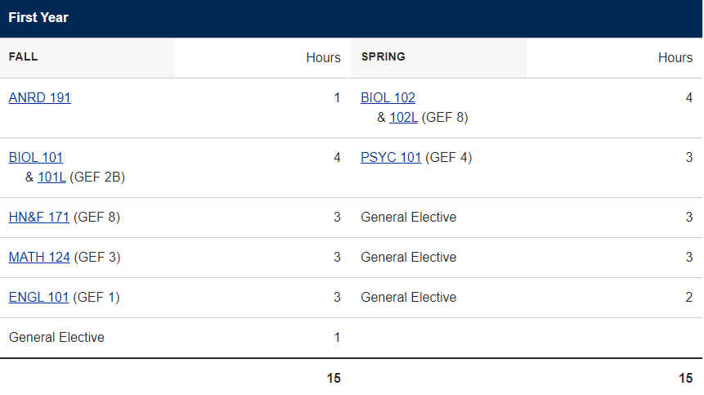
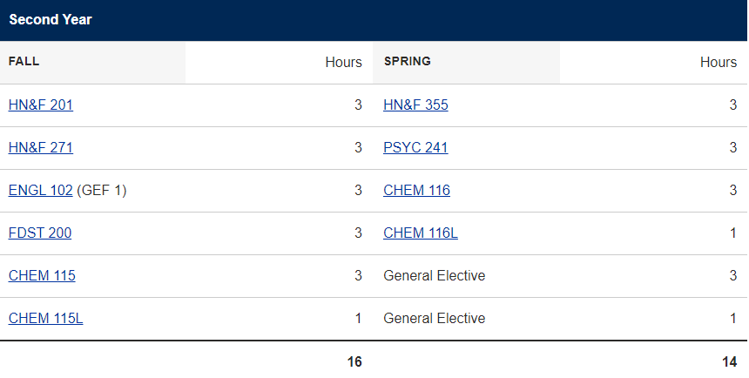

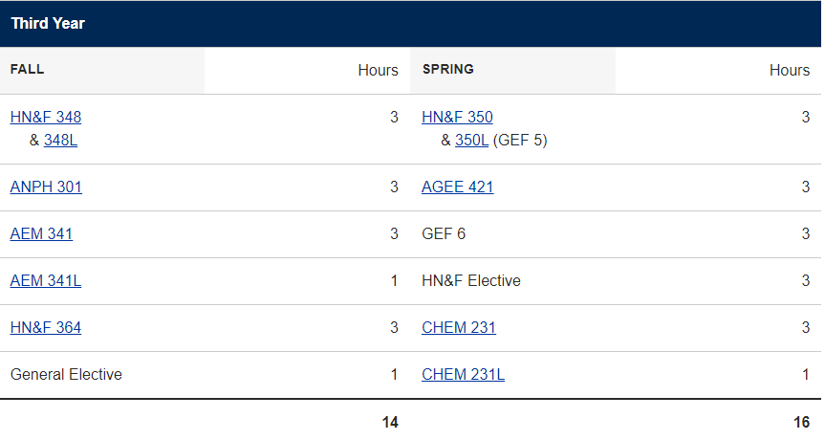
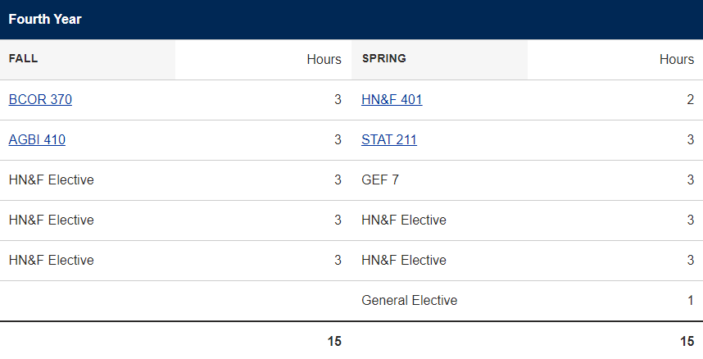

Appendix C: Suggested Plan of Study – AoE in Dietetics
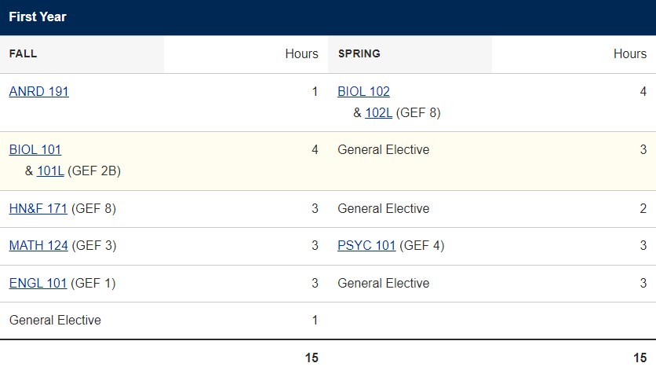

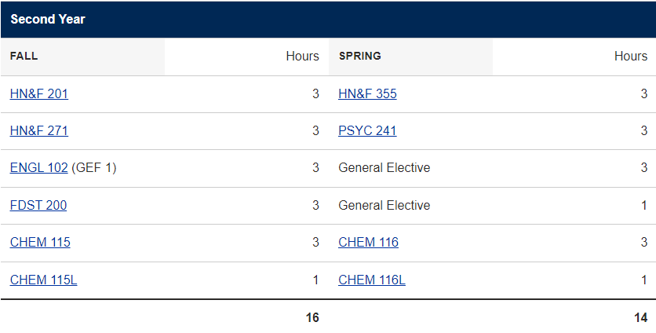
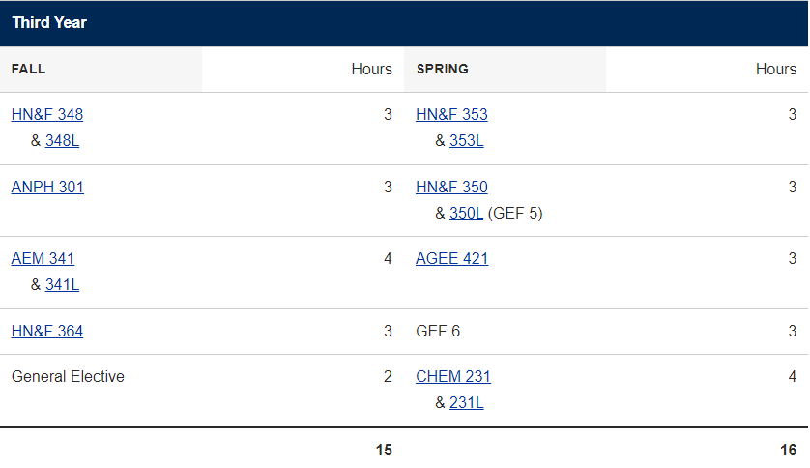

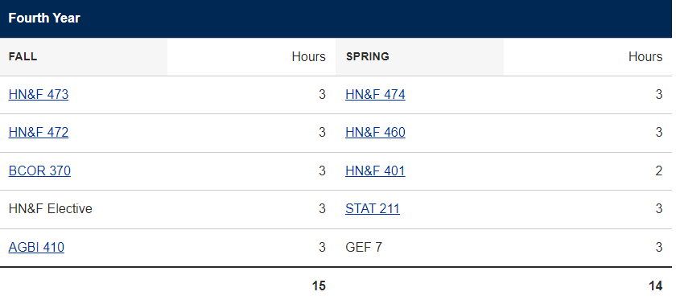

Appendix D: DICAS Computer Matching Calendar 2023-2024
Fall 2022 Match Calendar:
Date | Applicant’s Action
July 1, 2023 | D&D Digital opens to allow applicants to register on their website at www.dnddigital.com .
July 15, 2023 | DICAS Application opens to allow applicants to begin their application at https://portal.dicas.org  DICAS application fees are $50 for the first program designation, and $25 for each additional designation – paid at the time of application submission.
September 25, 2023 | Applicants must register online with D&D Digital, pay the computer match fee ($65) by credit card, and enter their contact information and Dietetic Internship preferences in D&D Digital by 11:59 pm Central Time, September 25, 2023.  DICAS portal closes and applications must be submitted by 11:59 pm Central time, September 25, 2023.
October 23- October 30, 2023 | Applicants who have registered for the match by September 25, 2023 can reorder Dietetic Internship priority rankings; however, no additional internships can be added to the list. No changes in DI rankings may be made after 11:59 pm Central Time on October 31, 2022. If you make other arrangements and will not be able to accept a match that may occur, you must notify D&D Digital in writing of your decision to withdraw from Dietetic Internship matching by October 31, 2022. The matching fee is not refundable.
November 5, 2023  Notification/Match Day! | Applicant matching results will be posted on www.dnddigital.com from 6:00 p.m. Central Time, Sunday, November 5, 2023, through Monday, November 6, 2023 (Appointment Day). This is the ONLY source of notification for applicants. Each applicant will receive either ONE MATCH or NO MATCH after Log In.  All applicants who receive ONE MATCH will find the matched DI program name and contact information to accept the matched appointment. The MATCHED DI program is planning that the MATCH will be accepted. Matched applicants must contact the DI Program by 6:00 PM (time zone of the program), Monday, November 6, 2023 to confirm acceptance of the MATCH. No arrangements should be made with any other DI programs.  Applicants who receive NO MATCH will be given other instructions.
November 6, 2023  Appointment Day | Matched applicants must contact the Dietetic Internship program by email, telephone or FAX on or before 6:00 PM (time zone of the program), Monday, November 6, 2023, to confirm acceptance of the MATCH. After this time, the program is under no obligation to hold the opening for the matched applicant.
November 7, 2023 | Beginning at 6:00 am Central Time, Dietetic Internship program directors may contact unmatched applicants who were originally entered on their list on the D&D website. If contacted, these appointments must be confirmed by November 7, 2023, at 8:00 pm Central Time.
November 7, 2023 | All appointments must be confirmed by applicants to dietetic internship program directors by 8:00 pm Central Time.
November 8, 2023 | Names of Dietetic Internship programs that did not fill their class and authorized release of their name will be posted on www.dnddigital.com .  Beginning at 11:00 am Central Time, the DICAS Application portal will allow non-matched applicants to update and submit their application to programs with remaining openings. Visit the Dietetic Internship Program’s website for program specific application instructions.

Spring 2024 Match Calendar
Date | Applicant’s Action
July 24, 2023 | DICAS Application opens to allow applicants to begin their application at https://portal.dicas.org  DICAS application fees are $50 for the first program designation, and $25 for each additional designation – paid at the time of application submission.
December 1, 2023 | D&D Digital opens to allow applicants to register on their website at www.dnddigital.com (Reg fee $65)
February 15, 2024 | Applicants must register online with D&D Digital, pay the computer match fee ($65) by credit card, and enter their contact information and Dietetic Internship preferences in D&D Digital by 11:59 pm Central Time, February 15, 2024.  DICAS portal closes and applications must be submitted by 11:59 pm Central time, February 15, 2024.
March 25-  April 1, 2024 | Applicants who have registered for the match by February 15, 2024 can reorder Dietetic Internship priority rankings in D&D Digital; however, no additional internships can be added to the list. No changes in DI rankings may be made after 11:59 pm Central Time on April 1, 2024. If you make other arrangements and will not be able to accept a match that may occur, you must notify D&D Digital in writing of your decision to withdraw from Dietetic Internship matching by April 1, 2024 at 11:59 pm CST. The D&D Digital matching fee is not refundable.
April 7, 2024  Notification/Match Day! | Applicant matching results will be posted on www.dnddigital.com from 6:00 p.m. Central Time, April 7, 2024, through April 8, 2024 (Appointment Day). This is the ONLY source of notification for applicants. Each applicant will receive either ONE MATCH or NO MATCH after Log In.  All applicants who receive ONE MATCH will find the matched DI program name and contact information to accept the matched appointment. Matched applicants must contact the DI Program by 6:00 PM (time zone of the program), Monday, April 8, 2023 to confirm acceptance of the MATCH. No arrangements should be made with any other DI programs.  Applicants who receive NO MATCH will be given other instructions.
April 8, 2024  Appointment Day | Matched applicants must contact the Dietetic Internship program by email, telephone or FAX on or before 6:00 PM (time zone of the program), Monday, April 8, 2023, to confirm acceptance of the MATCH. After this time, the program is under no obligation to hold the opening for the matched applicant.
April 9, 2024 | Beginning at 6:00 am Central Time, Dietetic Internship program directors may contact unmatched applicants who were originally entered on their list on the D&D website. If contacted, these appointments must be confirmed by April 9, 2024, at 8:00 pm Central Time.
April 10, 2024 | Names of Dietetic Internship programs that did not fill their class and authorized release of their name will be posted on www.dnddigital.com.  Beginning at 11:00 am Central Time, the DICAS Application portal will allow non-matched applicants to update and submit their application to programs with remaining openings.  Visit the Dietetic Internship Program’s website for program specific application instructions.

Appendix E: Pre-Professional Additional Course Requirements

If Pre-Med, these additional courses are required*:
CHEM 233 Organic Chemistry  +CHEM 233L Organic Chemistry Lab  +CHEM 234 Organic Chemistry  +CHEM 234L Organic Chemistry Lab | PHYS 101 Introductory Physics  + PHYS 102 Introductory Physics  (both lectures and labs)

If Pre-Med, these courses are suggested, sometimes required*:
GEN 371 Principles of Genetics (lecture and lab) | PHIL 331 Health Care Ethics
PUBH 101 Intro to Public/Community Health | PALM 200 Medical Terminology
PALM 205 Introduction to Human Anatomy  +PALM 206 Human Anatomy Laboratory | Foreign Language
NRSC 191 Introduction to the Neural Sciences

If Pre-PA, these additional courses are required*:
PALM 205 Introduction to Human Anatomy  +PALM 206 Human Anatomy Laboratory** | PALM 200 Medical Terminology
PSIO 241 Elementary Physiology
Or PSIO 441 Mechanisms of Body Function

If Pre-PA, these are suggested, sometimes required*:
CHEM 233 Organic Chemistry
+CHEM 233L Organic Chemistry Lab
+CHEM 234 Organic Chemistry
+CHEM 234L Organic Chemistry Lab
NRSC 191 Introduction to the Neural Sciences

*Always look at pre-requisite requirements for the specific medical school(s) you intend on applying to, as requirements may differ between programs.
**This is a web-based course. Some schools require anatomy and physiology to be taken in-person.
***Some schools do not allow AP credit to count towards prerequisites (i.e. AP biology or psychology).

Appendix F: Individual Assignments with Minimum Grade Requirements

Students must receive a minimum score (set by the instructor) on each of the below assignments within the respective courses in order to receive a verification statement upon graduation.
These requirements are monitored by ACEND, and aim to ensure all students have the same minimum understanding of the concepts the assignments correspond with:
Core Knowledge Statement | Course in which the knowledge is assessed | Assignment where knowledge is assessed
KRDN 1.1 Demonstrate how to locate, interpret, evaluate and use professional literature to make ethical, evidence-based practice decisions. | HN&F 401 Senior Seminar | Written literature review
KRDN 1.2 Select and use appropriate current information technologies to locate and apply evidence-based guidelines and protocols. | HN&F 364 Nutrition Education and Counseling | Major nutrition counseling session
KRDN 1.3 Apply critical thinking skills. | HN&F 473 Medical Nutrition Therapy I | Obesity Case Study
KRDN 2.1 Demonstrate effective and professional oral and written communication and documentation. | HN&F 401 Senior Seminar | Oral research presentation
KRDN 2.2 Describe the governance of nutrition and dietetics practice, such as the Scope of Practice for the Registered Dietitian Nutritionist and the Code of Ethics for the Profession of Nutrition and Dietetics. | HN&F 201 | Ethics in Dietetics case study assignment
KRDN 2.3 Assess the impact of a public policy position on nutrition and dietetics practice. | HN&F 472 Community Nutrition | Farm Bill Quiz
KRDN 2.4 Discuss the impact of health care policy and different health care delivery systems on food and nutrition services. | HN&F 473 Medical Nutrition Therapy I | Letter to legislator assignment
KRDN 2.5 Identify and describe the work of interprofessional teams and the roles of others with whom the registered dietitian nutritionist collaborates. | HN&F 474 Medical Nutrition Therapy II | Healthcare Professionals quiz
KRDN 2.6 Demonstrate cultural humility, awareness of personal biases and an understanding of cultural differences as they contribute to diversity, equity and inclusion. | HN&F 350 Cross-cultural cuisine | TED talk essay on counseling other cultures
KRDN 2.7 Describe contributing factors to health inequity in nutrition and dietetics including structural bias, social inequities, health disparities and discrimination. | HN&F 364 Nutrition Education and Counseling | Health equity reflection
KRDN 2.8 Participate in a nutrition and dietetics professional organization and explain the significant role of the organization. | HN&F 201 Professional Development in Dietetics | Participate in SAND, AND, or WVAND meeting with reflection
KRDN 2.9 Defend a position on issues impacting the nutrition and dietetics profession. | HN&F 201 Professional Dietetics | Position paper assignment
KRDN 3.1 Use the Nutrition Care Process and clinical workflow elements to assess nutritional parameters, diagnose nutrition related problems, determine appropriate nutrition interventions and develop plans to monitor the effectiveness of these interventions. | HN&F 473 Medical Nutrition Therapy I | ADIME hypertension case study
KRDN 3.2 Develop an educational session or program/educational strategy for a target population. | HN&F 364 Nutrition Education and Counseling | Education session
KRDN 3.3 Demonstrate counseling and education methods to facilitate behavior change and enhance wellness for diverse individuals and groups. | HN&F 364 Nutrition Education and Counseling | Major counseling project
KRDN 3.4 Practice routine health screening assessments, including measuring blood pressure and conducting waived point-of-care laboratory testing (such as blood glucose or cholesterol). | HN&F 473 MNT I | BG and BP practice lab
KRDN 3.5 Describe concepts of nutritional genomics and how they relate to medical nutrition therapy, health and disease. | HN&F 460 | Nutritional genomic quiz
KRDN 3.6 Develop nutritionally sound meals, menus and meal plans that promote health and disease management and meet client’s/patient’s needs. | HN&F 364 | Obesity Meal Plan
KRDN 4.1 Apply management theories to the development of programs or services. | HN&F 353 Food Service Systems Management | Menu planning project
KRDN 4.2 Evaluate a budget/financial management plan and interpret financial data. | HN&F 353 Food Service Systems Management | Financial Management Quiz
KRDN 4.3 Demonstrate an understanding of the regulation system related to billing and coding, what services are reimbursable by third party payers, and how reimbursement may be obtained. | HN&F 474 Medical Nutrition Therapy II | Billing and Coding quiz
KRDN 4.4 Apply the principles of human resource management to different situations. | HN&F 353 Food Service Systems Management | Human Resources case study project
KRDN 4.5 Apply safety and sanitation principles related to food, personnel and consumers. | HN&F 353 Food Service Systems Management | Food safety audit report
KRDN 4.6 Explain the processes involved in delivering quality food and nutrition services. | HN&F 353 Food Service Systems Management | Food delivery quiz
KRDN 4.7 Evaluate data to be used in decision-making for continuous quality improvement. | HN&F 348 Science of Food Preparation | Product Development Lab Report
KRDN 5.1 Perform self-assessment that includes awareness in terms of learning and leadership styles and cultural orientation and develop goals for self-improvement. | HN&F 364 Nutrition Education and Counseling | SMART goal assignment
KRDN 5.2 Identify and articulate one’s skills, strengths, knowledge and experiences relevant to the position desired and career goals. | HN&F 201 Professional Dietetics | LinkedIn Project
KRDN 5.3 Practice how to self-advocate for opportunities in a variety of settings (such as asking for needed support, presenting an elevator pitch). | HN&F 201 Professional Dietetics | Cover letter assignment
KRDN 5.4 Practice resolving differences or dealing with conflict. | HN&F 353 Foodservice Management | Conflict resolution question in HR assignment
KRDN 5.5 Promote team involvement and recognize the skills of each member. | HN&F 364 | Peer evaluation of work on education to a target audience assignment
KRDN 5.6 Demonstrate an understanding of the importance and expectations of a professional in mentoring and precepting others. | HN&F 201 Professional Dietetics | Guest speaker professional profile

